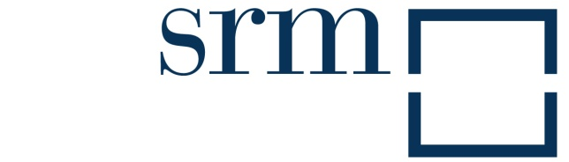

177, Via Toledo - 80134 Naples - Italy
Phone: +39 0817913758 - Fax: +39 817913817
comunicazione@sr-m.it - www.sr-m.it

President: Paolo Scudieri

General Manager: Massimo Deandreis

Board of Directors: Francesco Saverio Coppola, Gregorio De Felice, Franco Gallia, Pierluigi Monceri, Marco Morganti, Marco Musella, Piero Prado

The composition of the Scientific Committee is available at www.sr-m.it

Board of Auditors: Danilo Intreccialagli (president), Giovanni Maria Dal Negro, Lucio Palopoli

Supervisory Body (art.6 D.Lgs. 231/01): Gian Maria Dal Negro
Ethics Commitee (art.6 D.Lgs. 231/01): Lucio Palopoli

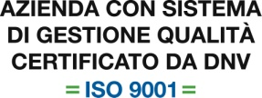
SRM uses a Quality Management System in compliance with the UNI EN ISO 9001 Regulations for the following fields: Studies, Research, Conferences in the southern financial and economic field: publishing development and management of magazine production

Shareholders
 |  | 
 |  | 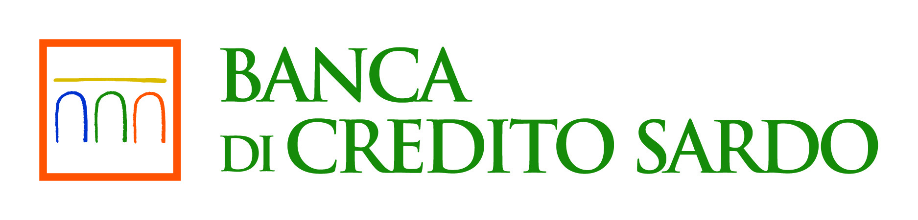
Founding and supporting member



***

Printed in Italy by Rubbettino print
in April 2014

